### KINDERGARTEN

* 1 pack index cards
* 1 backpack, labeled with student’s name
* 12 #2 pencils
* 12 small glue sticks
* 1 pack of 4 Dry Erase Markers
* 2 boxes of 24 crayons
* Clorox wipes
* 1 pair of headphones/earbuds
* 1 gallon and sandwich-sized Ziploc bags
* 2 boxes of facial tissue/Kleenex

### GRADE 1

* 2 boxes of 24 crayons
* 24 #2 sharpened pencils with erasers
* 2 pink pearl erasers
* 1 pair of headphones
* 3 Plastic Poly Folders: red, blue, green
* 1 black and white composition notebook
* 1 pack of 4 Dry Erase Markers
* 1 box of gallon size Ziploc bags
* 1 plastic pencil box (optional)
* 1 backpack, labeled with student’s name
* 2 boxes facial tissue/Kleenex
* 3 Packs of 100 Index Cards
* 5 Pack of 3x3 Post It Notes

### GRADE 2

* 2 boxes of 24 crayons
* 24 #2 sharpened pencils with erasers
* 1 backpack
* 1 package of Glue Sticks
* 2 boxes facial tissue/Kleenex
* 1 box of thin-tipped colored markers
* 1 two-pocket folder
* 1 box of colored pencils
* 1 pair of headphones

### GRADE 3

* 1 box of thin-tipped colored markers
* 1 box of colored pencils
* 24 #2 sharpened pencils with erasers
* 1 box of crayons
* 2 boxes of highlighters
* 1 large pink eraser
* 3 two-pocket folders
* 1 pair of headphones/earbuds
* 5 spiral notebooks: blue, green, yellow, black, red
* 1 two-inch binder
* 3 large boxes facial tissue/Kleenex
* 1 one-gallon zipper bag

### GRADE 4

* 1 box thin-tipped colored markers
* 1 box colored pencils
* 24 #2 sharpened pencils
* 1 box crayons
* 1 one-gallon zipper bags
* 1 large box facial tissues/Kleenex
* 5 two-pocket folders: blue, green, yellow, black, red
* 1 pack filler notebook paper
* 4 spiral notebooks: blue, green, yellow, red
* 2 pink pearl erasers
* 1 box of highlighters
* 1 4-pack dry erase markers

### GRADE 5

* 1 box thin-tipped markers
* 2 packs of filler notebook paper
* 1 box of colored pencils
* 24 #2 sharpened pencils with erasers
* 1 pink pearl eraser
* Eraser tops for pencils
* 1 pair of headphones or earbuds
* Dictionary
* 1 large box facial tissues/Kleenex
* Post-It notes

### Grade 6

* 6 Two--pocket folders: yellow, blue, green, red, purple, black
* 6 spiral notebooks: yellow, blue, green, red, purple, black
* 1 box facial tissues/Kleenex
* Hand sanitizer
* # 2 pencils (5 packs of 12)
* Pens (1 pack)
* Colored pencils (1 pack of 12)
* Clorox Wipes (2)
* Highlighters (4 pack)
* Ear Buds or Headphones
* 2 composition notebooks
* Dry Erase Markers (4 pack)

**GRADE 7 & 8**

* Dry Erase Markers (4 Pack)
* Hand Sanitizer
* Pencils (5 packs of 12)
* Pens (2 pack)
* Clorox Wipes (canister)
* Highlighters (4 pack)
* Ear Buds or Headphones
* Colored Pencils (1pack of 12)
* 2 spiral notebooks (blue for 7th grade, green for 8th grade)

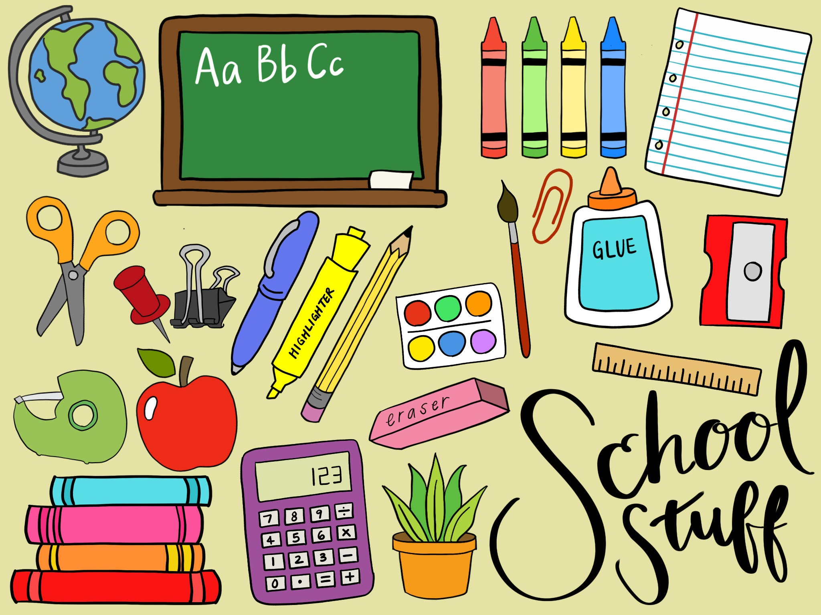

## MARY MCLEOD BETHUNE SCHOOL NO. 45

2023-2024 SCHOOL SUPPLY CHECKLIST